|  |
| --- |
| Question 01. |

1. 69,25,62,88,10,37,99

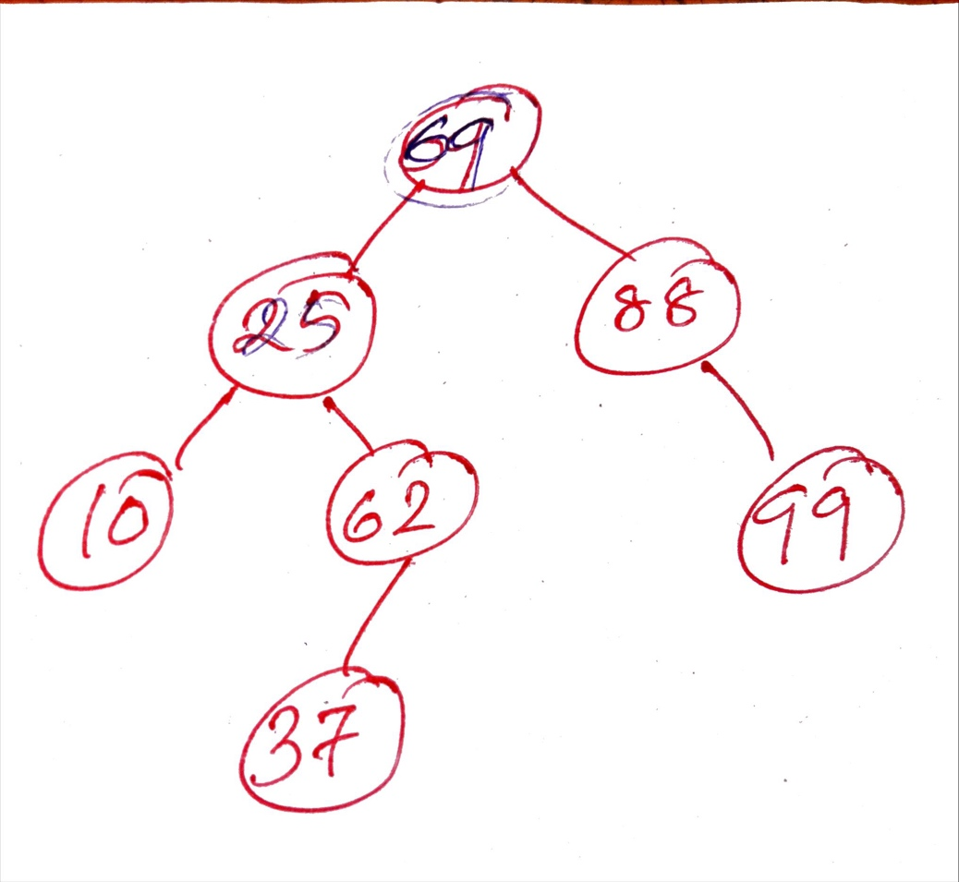

1. 32,24,6,2,39,41,30,145

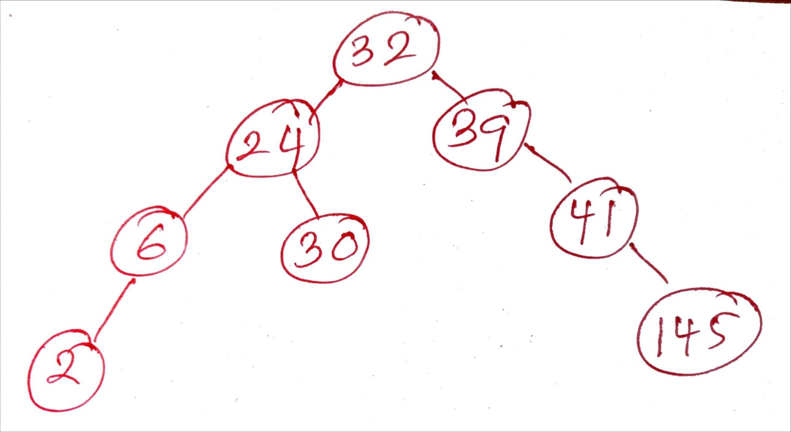

1. 120,46,7,2,31,39,23,40

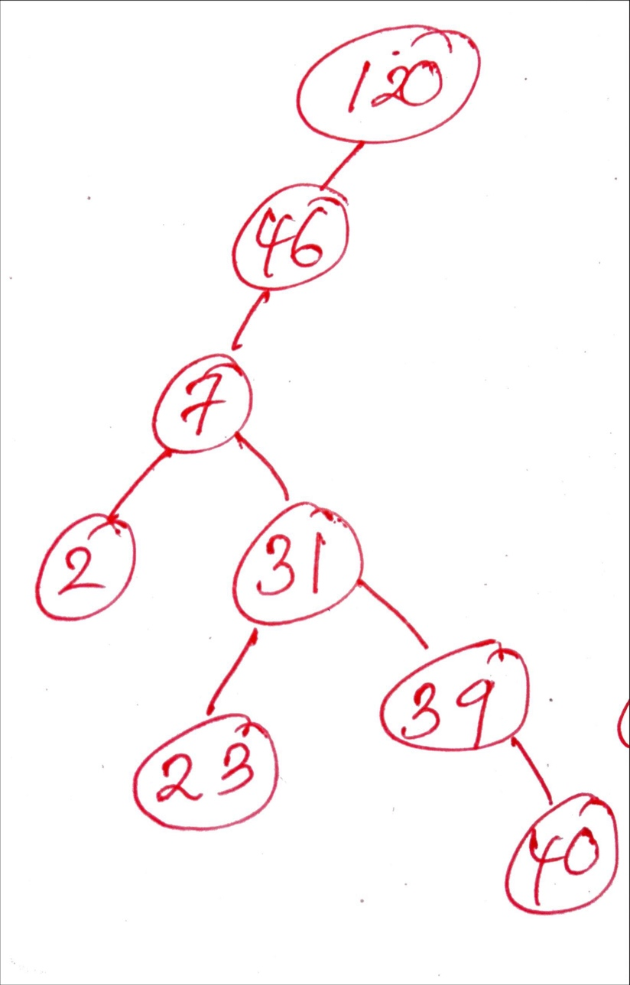

1. S, K, R, B, C, M, W, A, Z, X, D

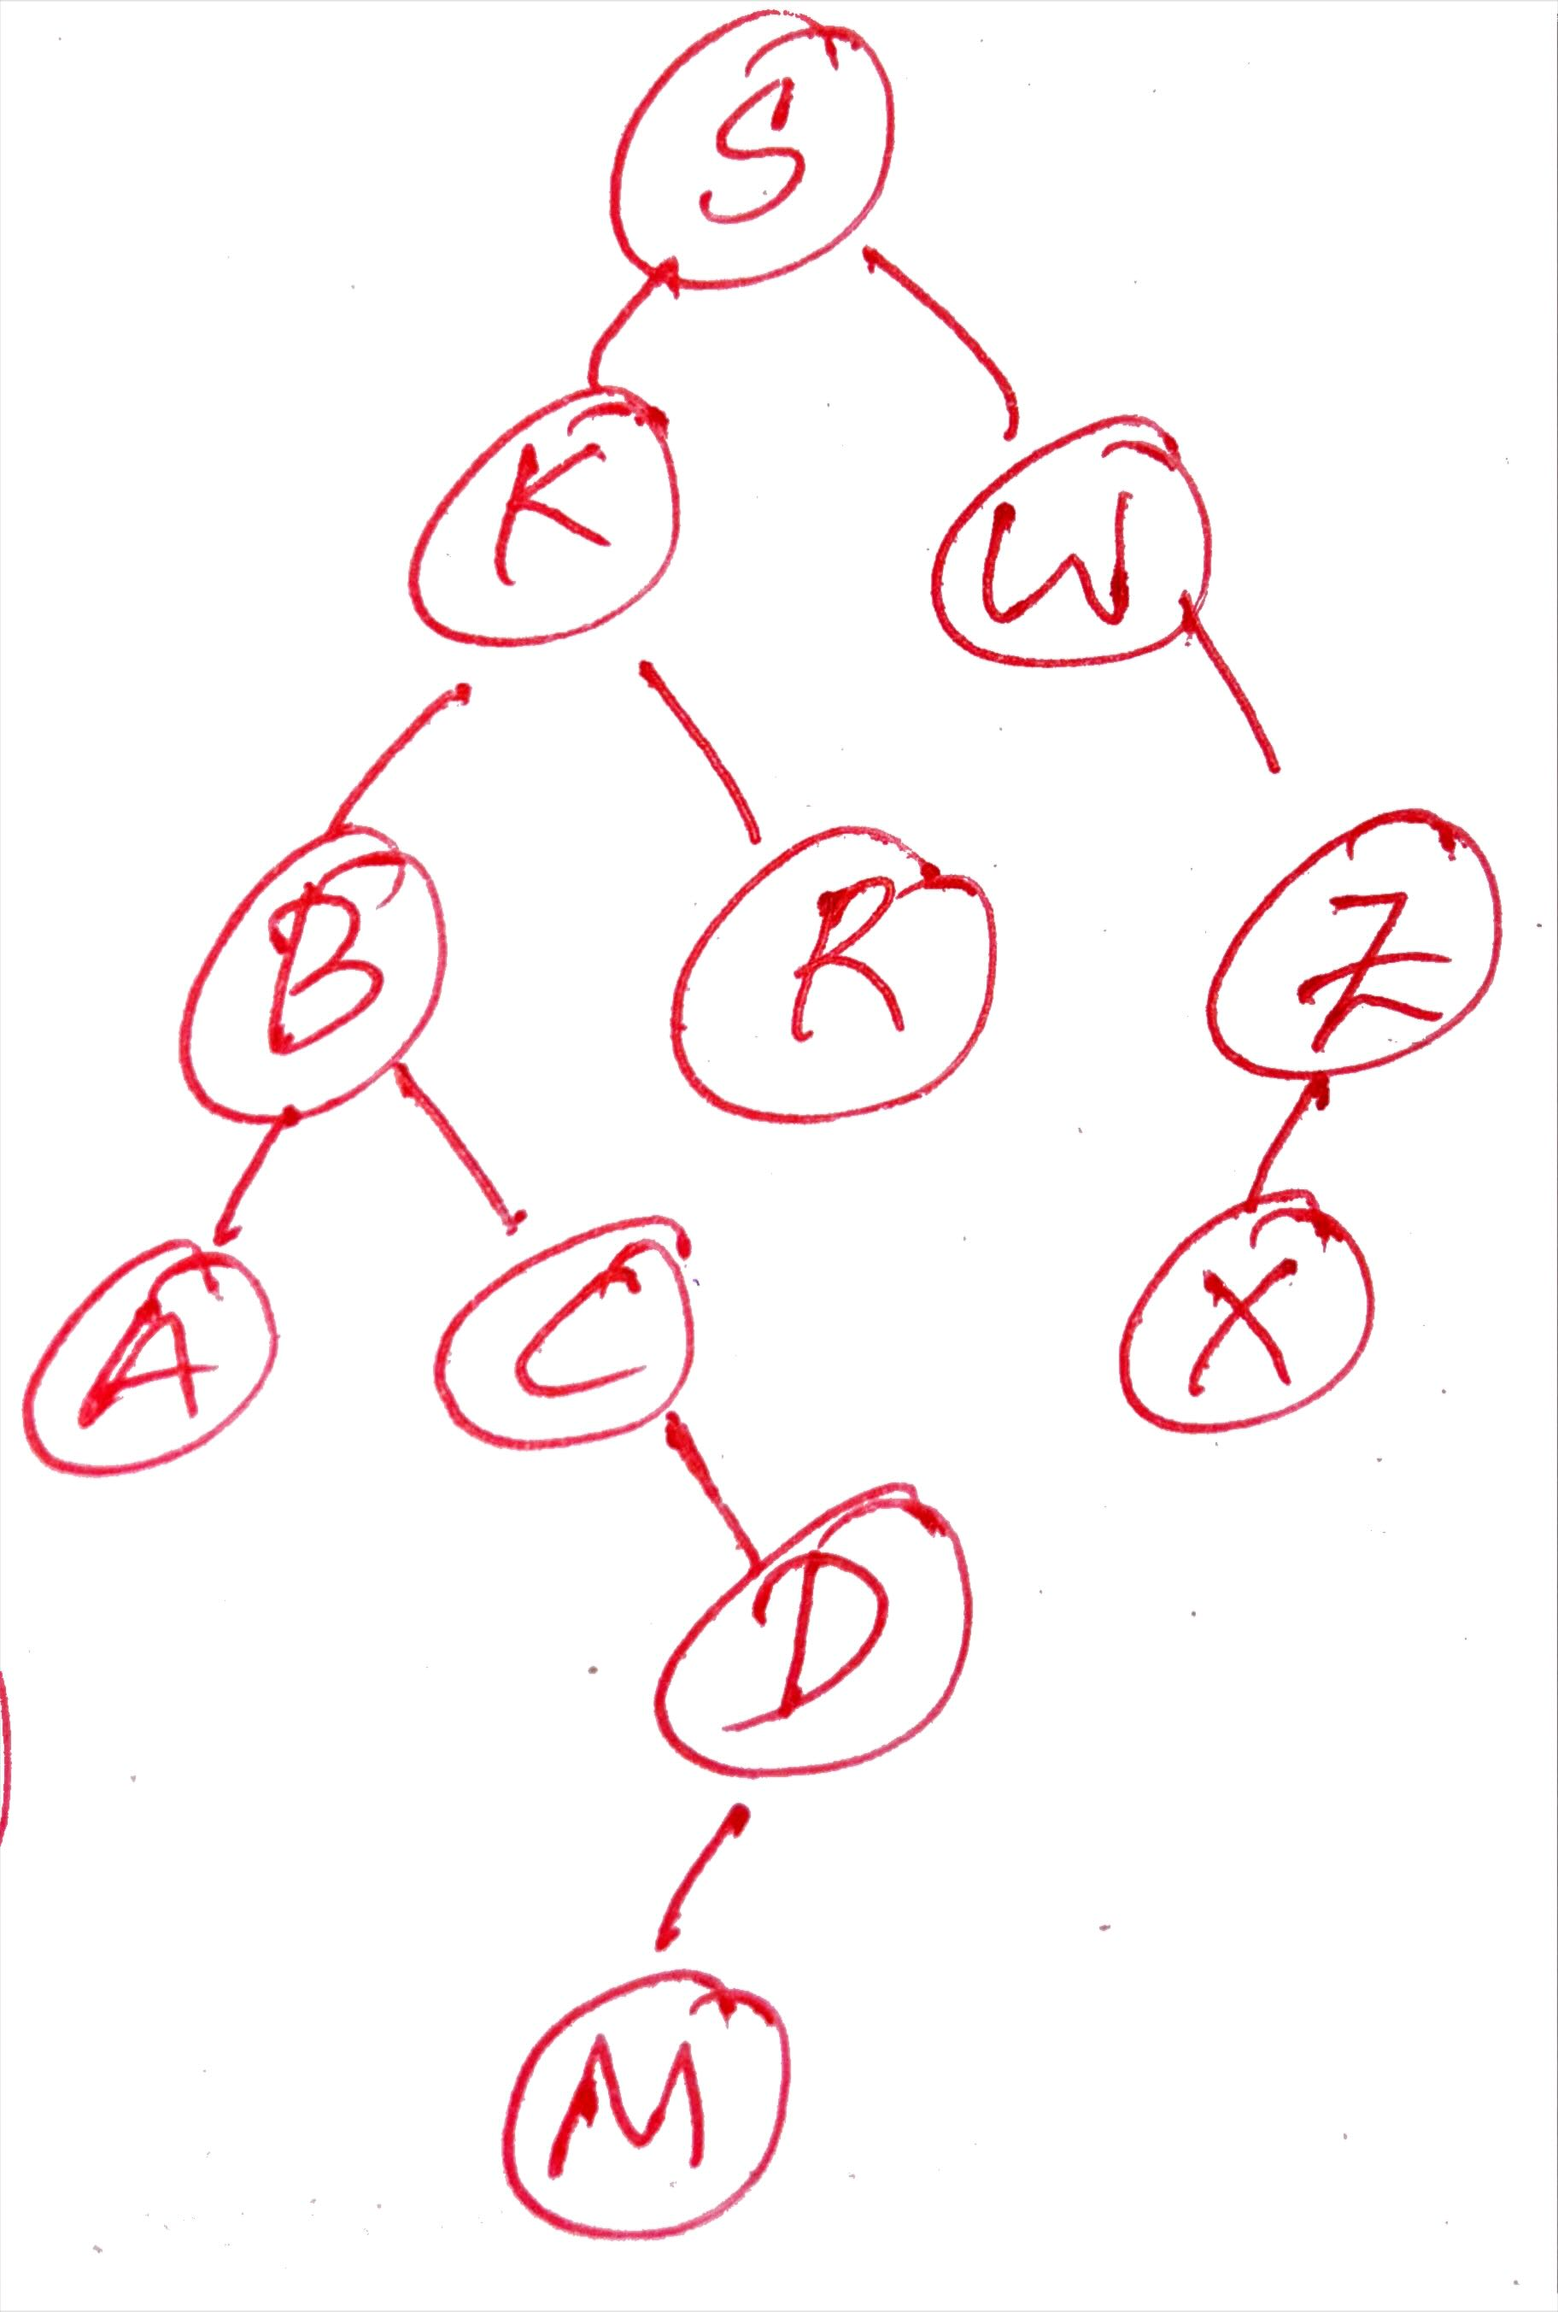

1. Mary, Tom, Bob, Wily, John, Mike, Harry, Kate, Sam, Sue

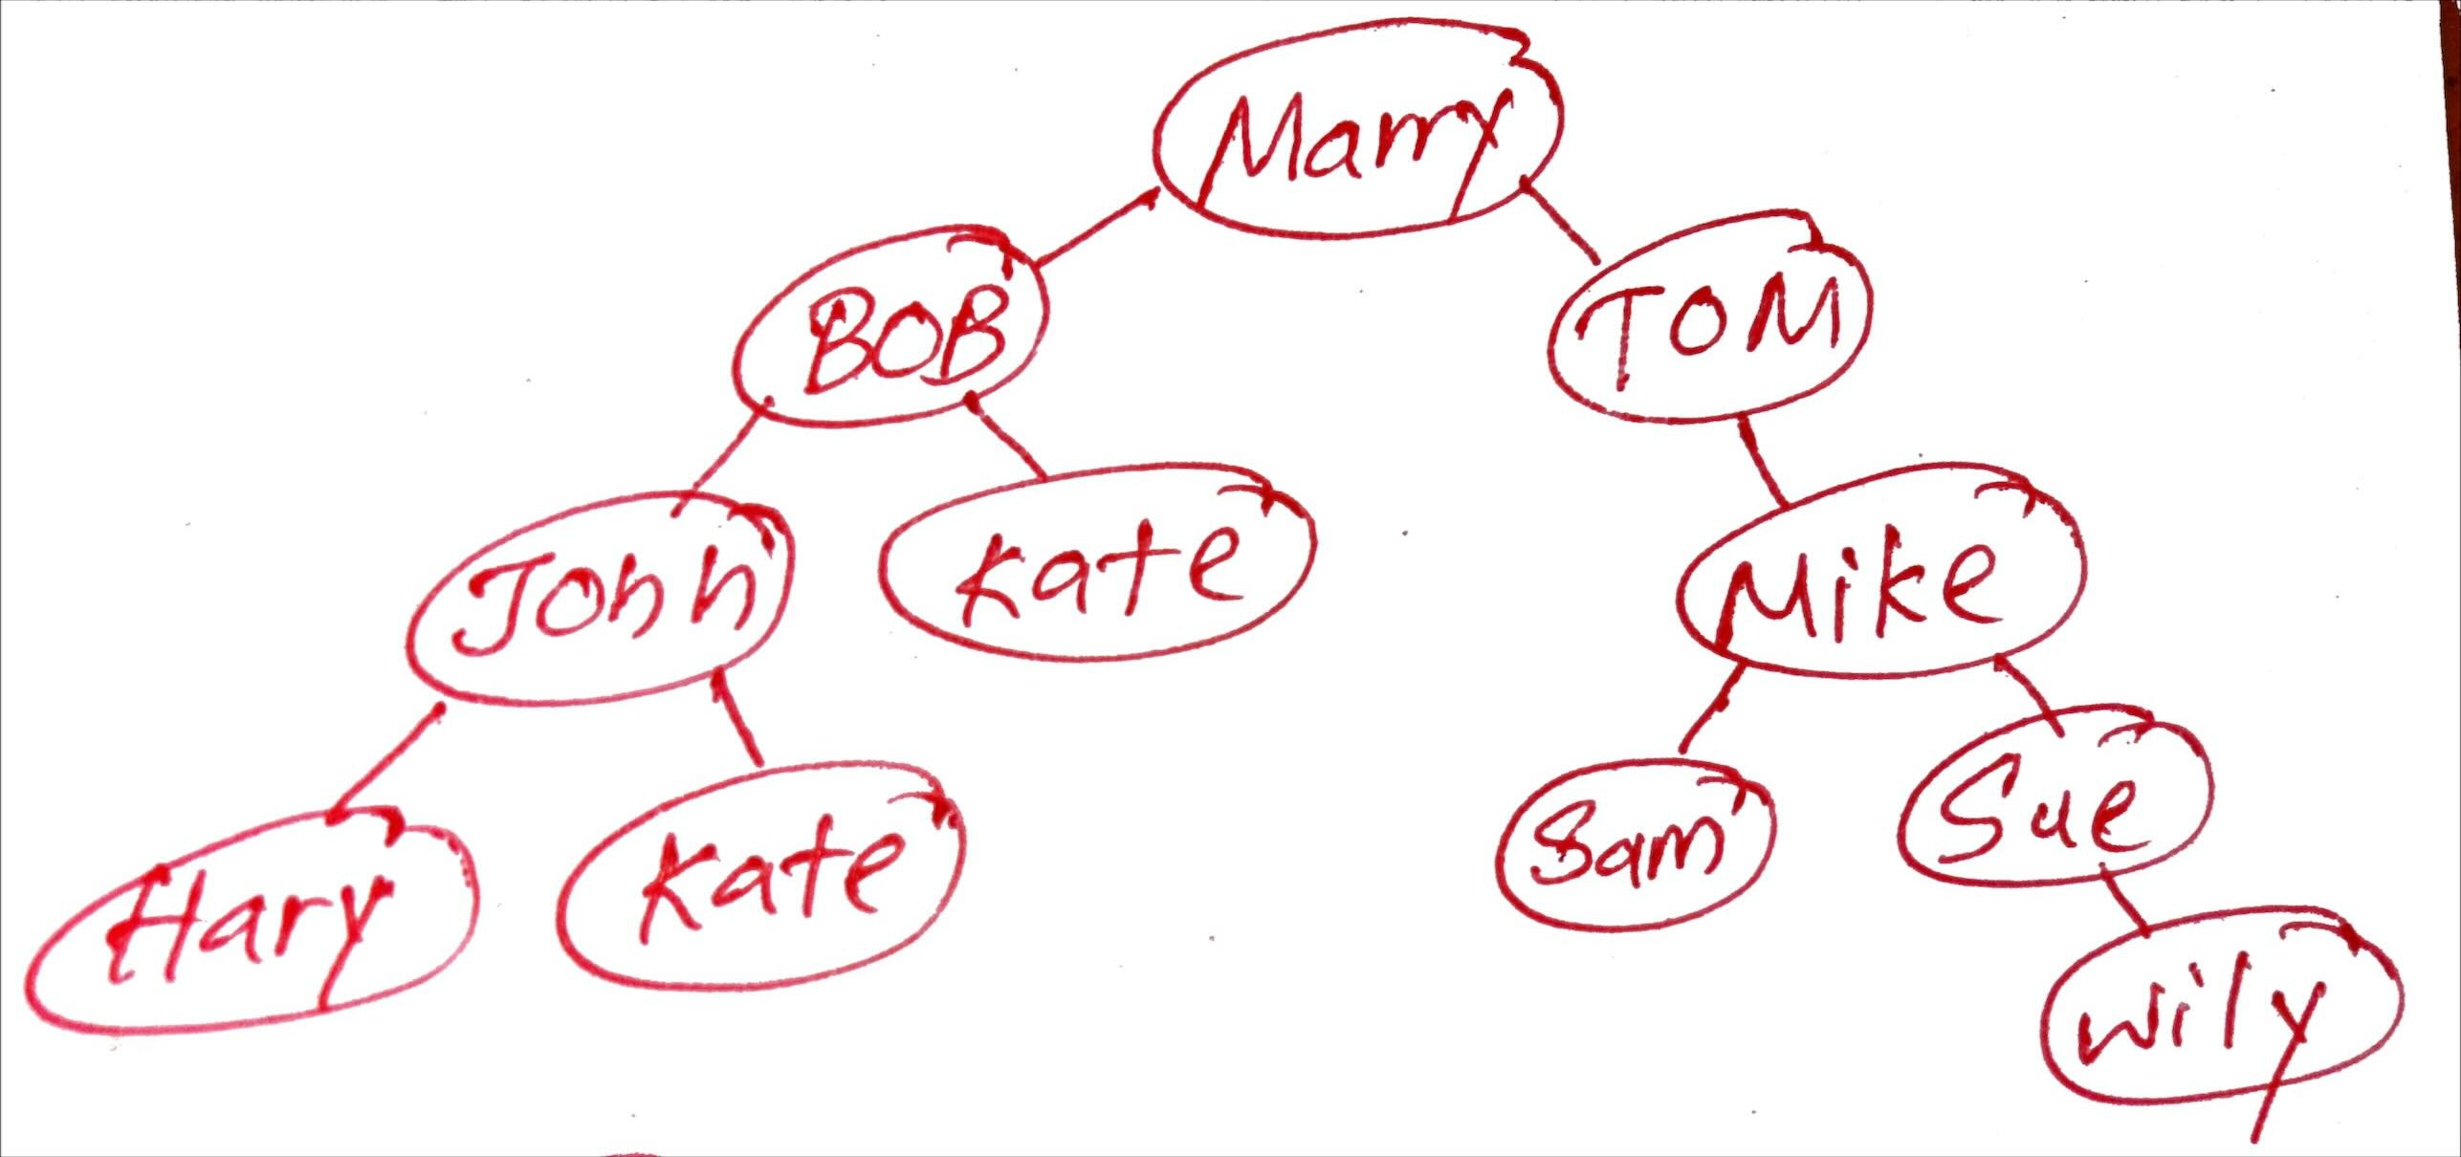

Question 01. B).

For Integers,

class **IntNode** {

int data;

IntNode left, right;

public IntNode(int data) {

this.data = data;

left = null;

right = null;

}

}

class **IntBST** {

IntNode root;

public void insert(int data) {

root = insertRec(root, data);

}

private IntNode insertRec(IntNode node, int data) {

if (node == null) return new IntNode(data);

if (data < node.data)

node.left = insertRec(node.left, data);

else if (data > node.data)

node.right = insertRec(node.right, data);

return node;

}

public void preorder(IntNode node) {

if (node != null) {

System.out.print(node.data + " ");

preorder(node.left);

preorder(node.right);

}

}

public void inorder(IntNode node) {

if (node != null) {

inorder(node.left);

System.out.print(node.data + " ");

inorder(node.right);

}

}

public void postorder(IntNode node) {

if (node != null) {

postorder(node.left);

postorder(node.right);

System.out.print(node.data + " ");

}

}

}

For Character,

class CharNode {

char data;

CharNode left, right;

public CharNode(char data) {

this.data = data;

left = null;

right = null;

}

}

class CharBST {

CharNode root;

public void insert(char data) {

root = insertRec(root, data);

}

private CharNode insertRec(CharNode node, char data) {

if (node == null) return new CharNode(data);

if (data < node.data)

node.left = insertRec(node.left, data);

else if (data > node.data)

node.right = insertRec(node.right, data);

return node;

}

public void preorder(CharNode node) {

if (node != null) {

System.out.print(node.data + " ");

preorder(node.left);

preorder(node.right);

}

}

public void inorder(CharNode node) {

if (node != null) {

inorder(node.left);

System.out.print(node.data + " ");

inorder(node.right);

}

}

public void postorder(CharNode node) {

if (node != null) {

postorder(node.left);

postorder(node.right);

System.out.print(node.data + " ");

}

}

}

**For Strings,**

class StrNode {

String data;

StrNode left, right;

public StrNode(String data) {

this.data = data;

left = null;

right = null;

}

}

class StrBST {

StrNode root;

public void insert(String data) {

root = insertRec(root, data);

}

private StrNode insertRec(StrNode node, String data) {

if (node == null) return new StrNode(data);

if (data.compareTo(node.data) < 0)

node.left = insertRec(node.left, data);

else if (data.compareTo(node.data) > 0)

node.right = insertRec(node.right, data);

return node;

}

public void preorder(StrNode node) {

if (node != null) {

System.out.print(node.data + " ");

preorder(node.left);

preorder(node.right);

}

}

public void inorder(StrNode node) {

if (node != null) {

inorder(node.left);

System.out.print(node.data + " ");

inorder(node.right);

}

}

public void postorder(StrNode node) {

if (node != null) {

postorder(node.left);

postorder(node.right);

System.out.print(node.data + " ");

}

}

}

public class **PracticalTutorial06** {

public static void main(String[] args) {

int[] seq1 = {69, 25, 62, 88, 10, 37, 99};

IntBST bst1 = new IntBST();

for (int num : seq1) bst1.insert(num);

System.out.println("Sequence i:");

System.out.print("Preorder: ");

bst1.preorder(bst1.root); System.out.println();

System.out.print("Inorder: ");

bst1.inorder(bst1.root); System.out.println();

System.out.print("Postorder: ");

bst1.postorder(bst1.root); System.out.println("\n");

int[] seq2 = {32, 24, 6, 2, 39, 41, 30, 145};

IntBST bst2 = new IntBST();

for (int num : seq2) bst2.insert(num);

System.out.println("Sequence ii:");

System.out.print("Preorder: ");

bst2.preorder(bst2.root); System.out.println();

System.out.print("Inorder: ");

bst2.inorder(bst2.root); System.out.println();

System.out.print("Postorder: ");

bst2.postorder(bst2.root); System.out.println("\n");

int[] seq3 = {120, 46, 7, 2, 31, 39, 23, 40};

IntBST bst3 = new IntBST();

for (int num : seq3) bst3.insert(num);

System.out.println("Sequence iii:");

System.out.print("Preorder: ");

bst3.preorder(bst3.root); System.out.println();

System.out.print("Inorder: ");

bst3.inorder(bst3.root); System.out.println();

System.out.print("Postorder: ");

bst3.postorder(bst3.root); System.out.println("\n");

char[] seq4 = {'S', 'K', 'R', 'B', 'C', 'M', 'W', 'A', 'Z', 'X', 'D'};

CharBST bst4 = new CharBST();

for (char ch : seq4) bst4.insert(ch);

System.out.println("Sequence iv:");

System.out.print("Preorder: ");

bst4.preorder(bst4.root); System.out.println();

System.out.print("Inorder: ");

bst4.inorder(bst4.root); System.out.println();

System.out.print("Postorder: ");

bst4.postorder(bst4.root); System.out.println("\n");

String[] seq5 = {"Mary", "Tom", "Bob", "Wily", "John", "Mike", "Harry", "Kate", "Sam", "Sue"};

StrBST bst5 = new StrBST();

for (String str : seq5) bst5.insert(str);

System.out.println("Sequence v:");

System.out.print("Preorder: ");

bst5.preorder(bst5.root); System.out.println();

System.out.print("Inorder: ");

bst5.inorder(bst5.root); System.out.println();

System.out.print("Postorder: ");

bst5.postorder(bst5.root); System.out.println();

}

}

